1.Create a 1 Dimensional array with 20 elements in float data type and use arange to fill the array with odd numbers from 1.

(i) Reshape array into 5X4 matrix

(ii) Display the elements of rows 2 to 5 and columns 1 to 3

(iii) Display the elements of 2 nd and 3 rd column

(iv) Display last 2 elements of last row

**program code**

import numpy as np

a=np.arange(1,41,2)

dtype=float()

print(a)

print("No.of rows and columns=",a.shape)

a = a.reshape(5,4)

print(a)

print("Display the elements of rows 2 to 5 and columns 1 to 3")

print(a[1:,:3])

print("Display the elements of 2 nd and 3 rd column")

print(a[:,1:3])

print("Display last 2 elements of last row")

print(a[4:,2:])

**output**

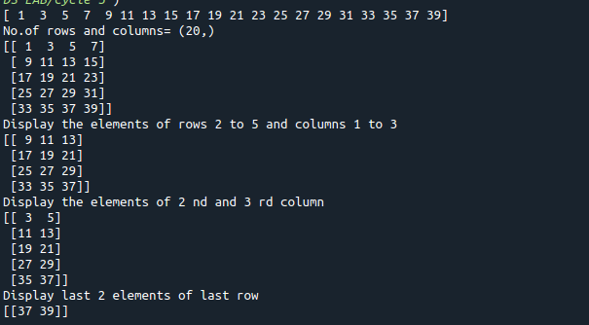

2. Write a program to perform bubble sort on a given set of elements

**program code**

def bubble_sort(list1):

for i in range(0, len(list1) - 1):

for j in range(len(list1) - 1):

if (list1[j] > list1[j + 1]):

temp = list1[j]

list1[j] = list1[j + 1]

list1[j + 1] = temp

return list1

n = int(input("Enter the size of the list: "))

list1 = list(int(num) for num in input("Enter the elements:").strip().split())[:n]

print("The unsorted list is: ", list1)

print("The sorted list is: ", bubble_sort(list1))

**output**

